Advertisements for Consumer Products in Ladies’ Magazine, 1893

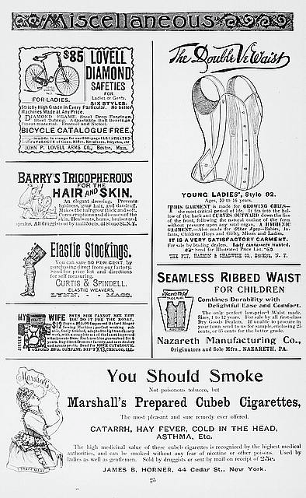

Godey. Advertisements from “Godey’s Lady’s Book and Magazine” for Bicycles, Corsets, Cigarettes, Elastic Stockings, and Other Products. 1893.
Prints and Photographs Division, Library of Congress. Web.

Investigation Question:
In this Document-Based Investigation, you will analyze source materials and investigate this question:

Were the benefits of new technologies from industrialization worth the costs?

Once you complete your investigation, you will select one of the following products:

• You are a historian selected to give the keynote address at a conference on “The Age of Inventions and Machines.” Your speech will focus on the changes brought about during the era and whether the positive outweighed the negative in terms of American life.
• You are the editor of a history book, The Wheels of Industry, which is a collection
of essays and photographs centering on the years between 1880 and 1920 in the
United States. Your introduction is titled “Was It Worth the Price?”

1. The Tread Mill, 1913

This 1913 political cartoon shows children tuning a wheel labeled “Profits on Child
Labor.”

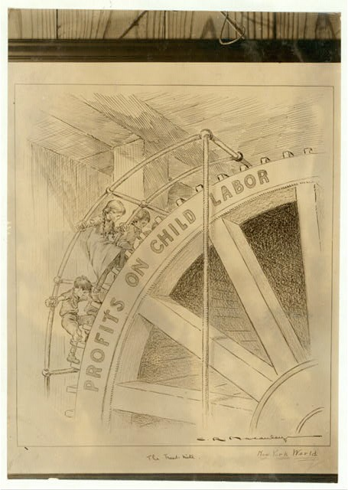

Macauley, C. R., artist. The Tread Mill. 1913. Prints and Photographs Division, Library of
Congress. Web.

2. Exhibit Panel, “Making Human Junk,” 1912

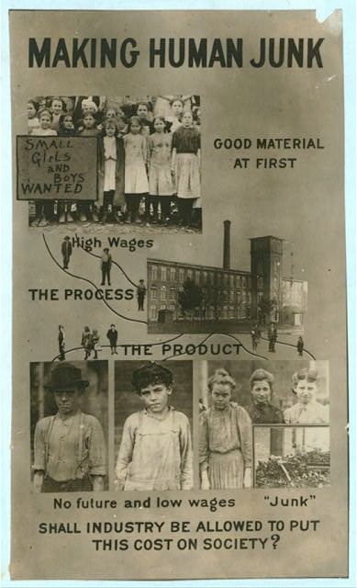

Hine, Lewis Wickes, photographer. Exhibit Panel. 1913 or 1914. Prints and Photographs Division,
Library of Congress. Web.

3. Excerpt from an Interview with Harry Reece, Late 1800s

Harry Reece was raised on an Illinois farm in the late 1800s. In this interview, Reece recalls a trip to Chicago, Illinois, and discusses his first experience with an electric trolley.

I was born in the middle west. Out in the state of Illinois . . . We lived on a farm, and even telephones were curiosities to myself and the country boys of my age. Electric lights were something to marvel at . . . the old Edison phonograph with its wax cylinder records and earphones was positively ghostly...and trolley cars, well they too were past understanding! Speaking of trolley cars reminds me of a trip to the ‘city’ once when I was about a dozen years old. My father and a neighbor, Old Uncle Bill Brandon, had to go up to the Big Town, which was Chicago, on some sort of business
. . . and Father rewarded me by taking me along.

You can imagine what a time I had seeing things I’d never seen before, in fact had only dreamed about or heard about. Curiosity wasn’t the name for it. Speechless incredulity came nearer describing my emotions . . . But when I saw my first trolley car slipping along Cottage Grove Avenue in Chicago . . . without horses or engine or
. . . well it was just too darned much for me. I didn’t know what to think.

Uncle Bill Brandon was almost as much in doubt as I was myself--and Uncle Bill Brandon was, locally, that is out on the farm, considered a very, very wise and sophisticated person. And he was wise, too. . . .Uncle Bill could understand horses, hogs and cattle, steam engines, army mules and row boats, and such thing--but that trolley car, with the little spinning wheel at the end of the pole, spinning along against the electric wire above it; was too much for him. Still, he didn’t want to confess ‘that there was any doggone thing on earth that he couldn’t figure out!’ And he didn’t want to show his ‘ignorance’ and especially to my Father or to myself, a twelve year old . . .

I wasn’t so anxious to conceal my own ignorance, so with legitimate curiosity asked my Father and Uncle Bill what made the thing go.

‘Gosh a’mighty, can’t you see what makes her go?’ [Uncle Bill] exclaimed, ‘It’s that danged rod stickin’ up out of the top of her. People’s gettin’ so cussed smart these days all they need to do to run a street car is to got a fish-pole and stick it up out of the roof of her!’

“Harry Reece (Daca) . . . .His Story.” American Life Histories: Manuscripts from the Federal Writers’ Project, 1936–1940.
Manuscript Division. Library of Congress. Web.

4. Ad: Coming our Way, 1899

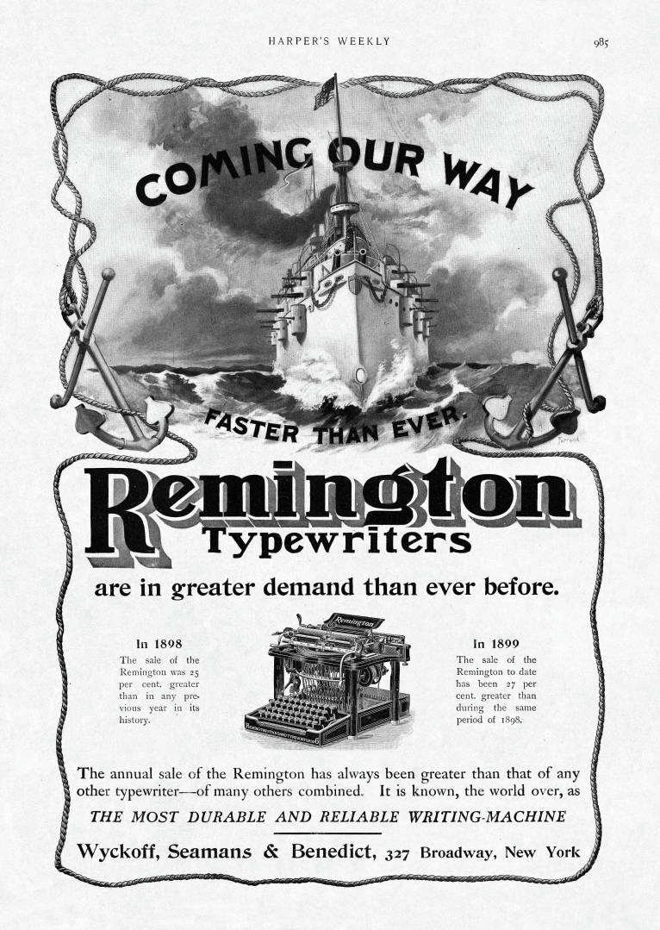

Wyckoff, Seasmans & Benedict. “Faster Than Ever,” full-page illustrated ad, Remington typewriter. Illustrations, Photographs and Text from Harper’s Weekly, September 30, 1899. Harpweek. Web.

5. Excerpt from Report on Industrial Accidents in Pittsburgh, 1907

In a year when industrial activity was at its height, — that is, from July 1, 1906, to June 30, 1907, — 526 men were killed by work-accidents in Allegheny County, Pennsylvania [Pittsburgh area]. During three months, April, May and June, of the same year, the hospitals of the county received over 509 men injured in such accidents. . . .

There is no bright side to this situation. By industrial accidents, Allegheny County loses more than 500 workmen every year, of whom nearly half are American born, 70 per cent are workmen of skill and training, and 60 per cent have not yet reached the prime of their working life. Youth, skill, strength, — in a word, human power, — is what we are losing.

Is this loss a waste? This is a question which Pittsburgh and every industrial district must answer. If it is merely an inevitable loss in the course of industry, then it is something to grieve over and forget. If it is largely, or half, or partly unnecessary, — a waste of youth and skill and strength, — then it is something to fight about and not forget.

Eastman, Crystal. “The Pittsburgh Survey.” Work Accidents and the Law. Ed. Paul Underwood Kellogg. New York. Survey
Associates. 1916. Web.

6. Logging in Cascade Mountains, Washington State, 1921

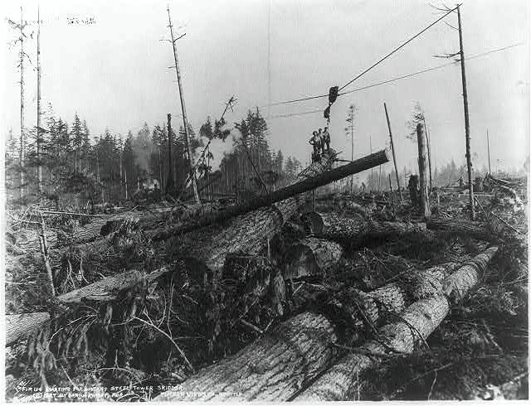

Kinsey, Darius, photographer. Lumbering in the Cascade Mountains, near Seattle, Wash. 1921. Prints and Photographs Division,
Library of Congress. Web.

7. Steam Engine, early 1900s

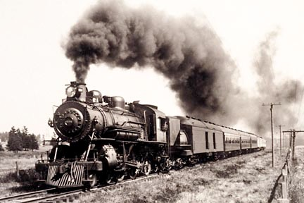

Steam Locomotive. 2004. Discovery Education. Web.

8. Factory Smokestacks, Syracuse, New York, between 1890 and 1901

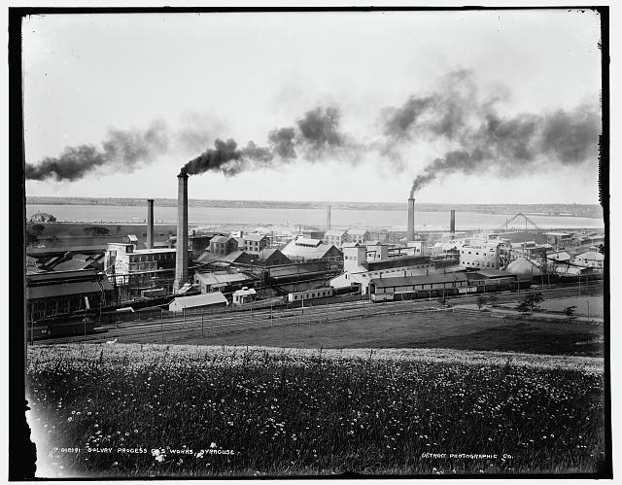

Detroit Publishing Company. Solvay Process Co.’s Works, Syracuse. 1890-1901. Prints and Photographs Division, Library of
Congress. Web.

9. Children Posing with New Bicycles and Tricycles, between 1910 and 1920

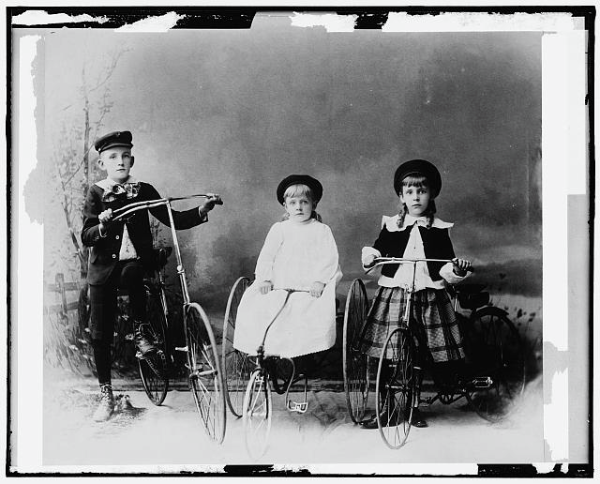

Detroit Publishing Company. Children Posed with Bicycle and Tricycles. 1910-1920. Prints and Photographs Division, Library of
Congress. Web.

10. Cartoon “After Vacation—The Discovery of the Home,” 1905

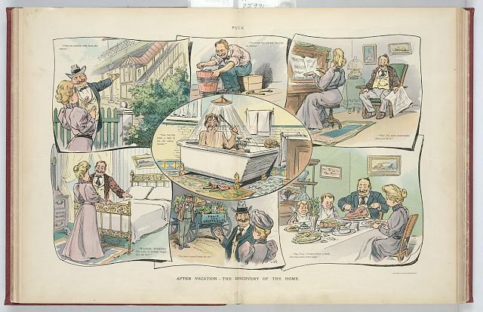

Pughe, J. S., artist. After Vacation—The Discovery of the Home. New York: J. Ottmann Lith. Co., Puck Bldg., 1905. Prints and
Photographs Division, Library of Congress. Web.

11. A Pleasant Evening at Home, 1902

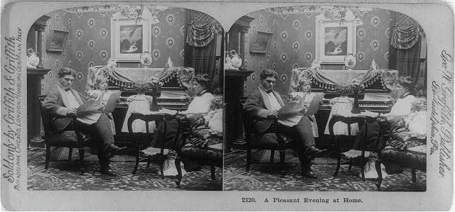

Griffith, Geo. W, publisher. A Pleasant Evening at Home. 1902. Prints and Photographs Division, Library of Congress. Web.

Already Know/Need to Know

Investigation Question: Were the benefits of new technologies from industrialization worth the costs?

Information I Already Know  About This Topic | Information I Still Need to Know to  Answer the Investigation Question

Document-Based Investigation Resource Sheet

Directions: As you analyze the sources in your packet, complete the organizer below.

Investigation Question: Were the benefits of new technologies from industrialization worth the costs?

Basic Information | The Source’s | The Source and the
About the Source | Overall Message | Investigation Question
- What is this? | - How would I summarize the content or | - Does this source help me address
- Who created it? When? | overall message of this primary | the investigation question? If so,
- What was its purpose? | source? | how? If not, why not?
- Who was the desired audience? | - Which parts of the source are facts?
 | Which parts are opinions? What biases
 | does the source reveal?

Investigation Question: Were the benefits of new technologies from industrialization worth the costs?

Basic Information  About the Source | The Source’s  Overall Message | The Source and the  Investigation Question

Investigation Question: Were the benefits of new technologies from industrialization worth the costs?

Basic Information  About the Source | The Source’s  Overall Message | The Source and the  Investigation Question

Investigation Question: Were the benefits of new technologies from industrialization worth the costs?

Basic Information  About the Source | The Source’s  Overall Message | The Source and the  Investigation Question

Investigation Question: Were the benefits of new technologies from industrialization worth the costs?

Basic Information  About the Source | The Source’s  Overall Message | The Source and the  Investigation Question

Putting It All Together

Investigation Question: Were the benefits of new technologies from industrialization worth the costs?

Use the space below to respond directly to the investigation question. Thesis statement

FIRST POINT OF SUPPORTING EVIDENCE:

Why is this point important?

Which sources demonstrate this point?

SECOND POINT OF SUPPORTING EVIDENCE:

Why is this point important?

Which sources demonstrate this point?

THIRD POINT OF SUPPORTING EVIDENCE:

Why is this point important?

Which sources demonstrate this point?

COUNTERPOINTS:

What will people who disagree with your position argue?

Why is your argument more convincing?

